**LEBANESE AMERICAN UNIVERSITY**

**USAID – HIGHER EDUCATION SCHOLARSHIP PROGRAM**

**HES - Volunteering Program Verification Form**

This form is to be used to document volunteering hours. If a student volunteers for multiple organizations, a separate form must be used for each organization. **This form must be turned in by the 28th of each month, the latest.**

I certify that the scholar Maisam Osama Aloubaidi completed a total of 3 hours of service at InnovaThrive.

The hours were completed hours as per the below:

Hours # 0 (date) _2/12 – 6/12_ (initials of supervisor) __A.K.___

Hours # 0 (date) _9/12 – 13/12_ (initials of supervisor) __A.K.___

Hours # 0 date) _16/12 – 20/12 (initials of supervisor) __A.K.___

Hours # 3 date) _23/12 - 27/12 (initials of supervisor) __A.K.___

Brief description of the activities the scholar performed or participated in:

My task involves researching AI's role in language learning, focusing on its applications, advantages, and future potential. This includes examining how AI personalizes lessons and integrates VR for immersive experiences, supported by statistical evidence like a 30% increase in vocabulary retention and faster learning rates. It also involves exploring AI’s benefits, such as tailored learning for diverse paces and increased accessibility for remote learners. Future research will address long-term impacts, enhanced personalization, cultural immersion, and ethical considerations

Written feedback about the scholar’s performance:

Maisam demonstrates excellent critical thinking and research skills, especially in exploring AI's role in personalized language learning. Her ability to analyze complex topics like VR integration and the impact on learning rates shows strong analytical abilities and forward-thinking.

Please rate the overall performance of the scholar at your organization:

|  |  |  |  |
| --- | --- | --- | --- |
|  | Mastery (5) | Proficient (3) | Emerging (1) |
| **Problem solver** | X |  |  |
| **Engaged & Committed** | X |  |  |
| **Open-minded & multicultural** | X |  |  |

Signature

& stamp

__________________________

_

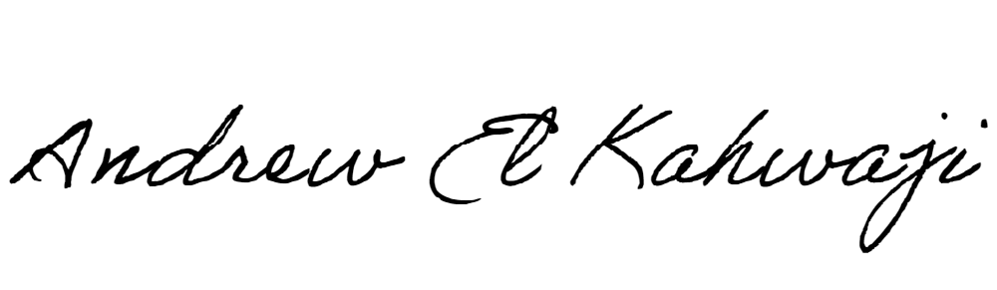

Printed Name _Andrew El Kahwaji_

Date __26/12/2024___

Email __andrew.lifesculptor.coo@gmail.com __

Phone __+961 71 914 378__